Test case title: Login happy path
Test case id: TC07

Description: Test case to validate the happy path for an user trying to log into the application, using a valid email and password combination.

Steps | Expected result
Navigate to Login page: https://juice-shop.herokuapp.com/#/login | User should be able to access app’s login page.
In the email field, type a valid email address for an already existent user | User should be able to locate and type into the email field.
In the password field, type the password for the user | User should be able to locate and type into the password field.
Locate the button with the text “Log in” and click it. | User should be able to locate and interact with the submit button.

Final expected result: After using a correct email/password combination when trying to log in, and clicking the “Log in” button, the app should redirect the user into the home page (https://juice-shop.herokuapp.com/#/search), and the button “Your Basket” should be present at the top right corner.

Examples:

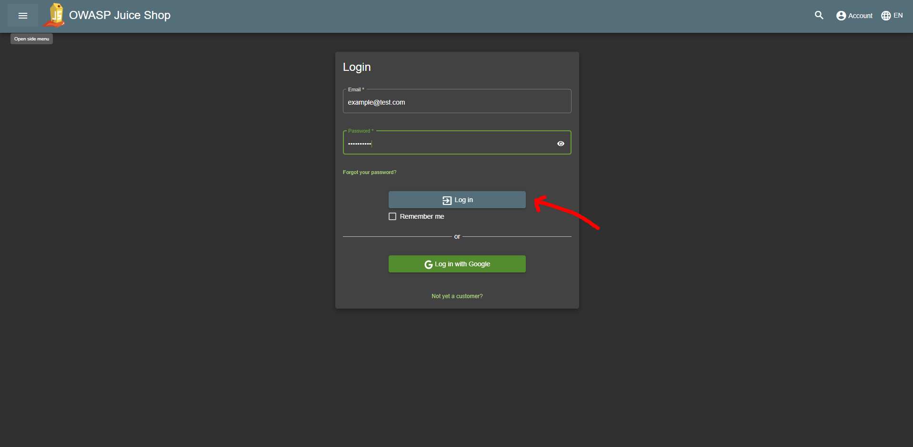
Entering valid email/password combination and clicking “Log in”
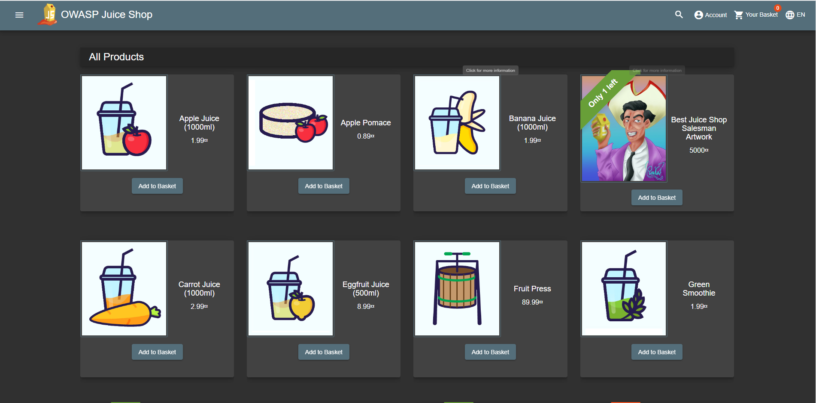
Home page after successful login

